**DAILY ONLINE ACTIVITIES SUMMARY**

|  |  |  |  |  |  |  |  |
| --- | --- | --- | --- | --- | --- | --- | --- |
| **Date:** | **26-05-2020** | | | | **Name:** | **Gudugunti Anirudh** | |
| **Sem & Sec** | **IV - 'A'** | | | | **USN:** | **4AL18CS023** | |
| **Online Test Summary** | | | | | | | |
| **Subject** | | **Design analysis and algorithms** | | | | | |
| **Max. Marks** | | **30** | | **Score** | | **22** | |
| **Certification Course Summary** | | | | | | | |
| **Course** | **Python in ML** | | | | | | |
| **Certificate Provider** | | | **Great learning academy** | **Duration** | | | **2hrs** |
| **Coding Challenges** | | | | | | | |
| **Problem Statement :** 1. Number of permutations of a given string  2. Number of subarrays of the given type  **Problem Statement 2:** Write a C program to check whether the two strings are Anagram or not. | | | | | | | |
| **Status: executed** | | | | | | | |
| **Uploaded the report in Github** | | | | **Yes** | | | |
| **If yes Repository name** | | | | **https://github.com/Anirudh23-23/Daily-progress** | | | |
| **Uploaded the report in slack** | | | | **Yes** | | | |

**Online Test Summary**: The online test was from module 2 which was about divide and conquer algorithms and decrease and conquer algorithms. There were 30 questions and the duration were 45 minutes. The questions were optimal and were easy. The score that I got in the test is 22/30.

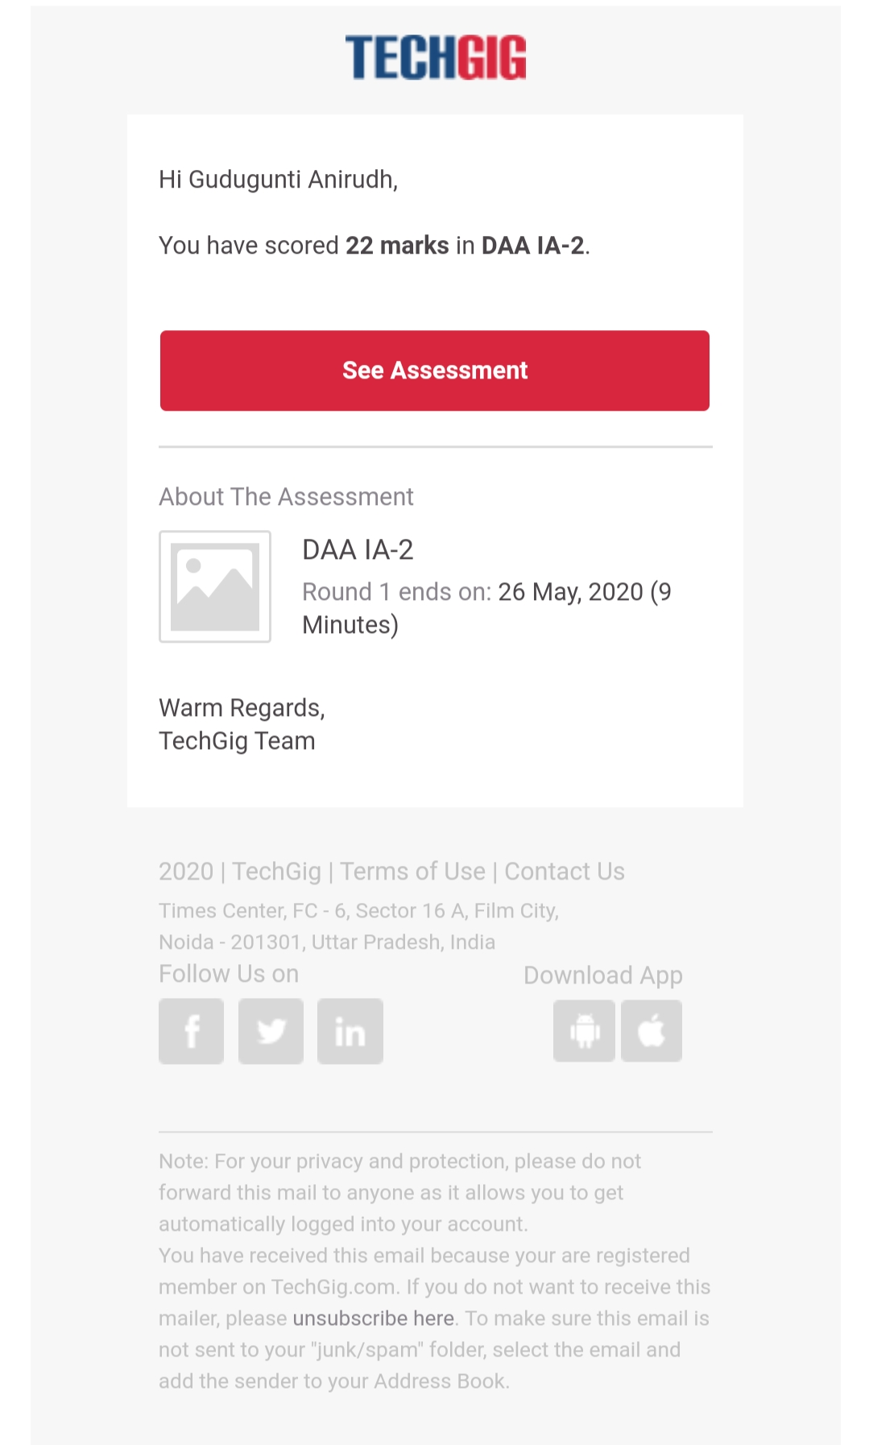

**Online Certification course Summary**:

**1. Detailed instructions about NumPy.**

**2. It's a package for doing math operations in advanced manner.**

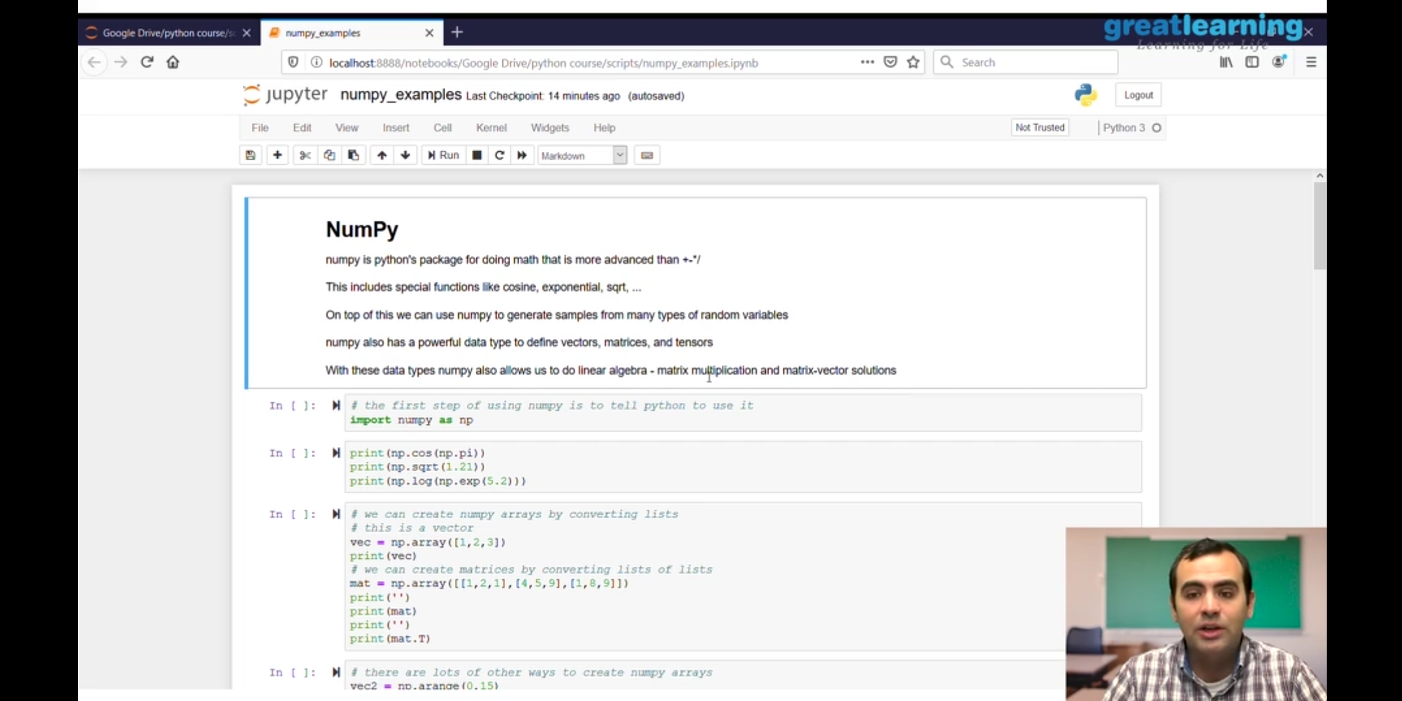

3. NumPy also allows to do linear algebra,matrix multiplication and many other mathematical operations.

**CODING CHALLENGES DETAILS**:

Problem 1: (Using JAVA) Given an array A of size N where the array elements contain values from 1 to N with duplicates, the task is to find total number of subarrays which start and end with the same element.

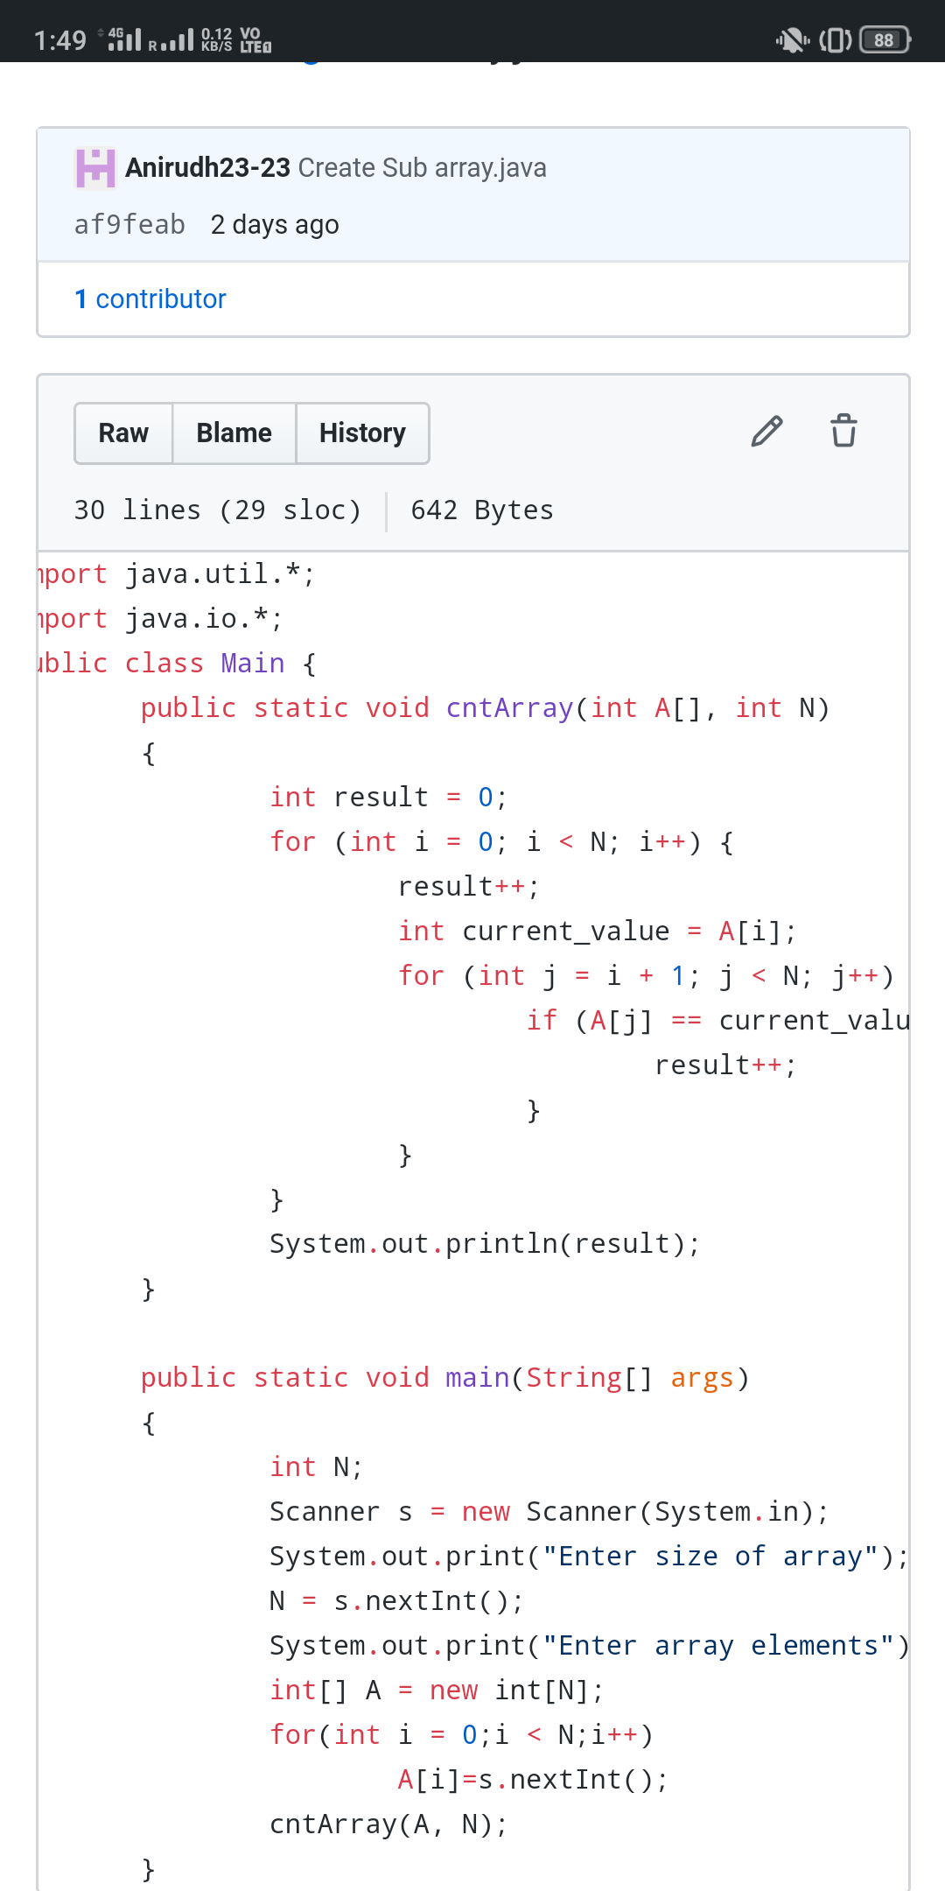

Problem 2:(using c language) check the permutations of the given input.

